**CS 5551 Advance Software Engineering**

**FIRST INCREMENT REPORT**

**Locus**

**Team#7**

**Venkatesh Pallay**

**Sowmith Reddy Pentaparthy**

**Rohit Nagulapati**

**Abhilash Reddy Gaddam** **Project Proposal**

**Project Title: Locus**

PROJECT GOAL AND OBJECTIVES:

MOVITATION:

How important is your vehicle to you? Do you treat it as your family member, if so what if your friend requests for the car to go for a ride with his girlfriend? Don’t worry if you have “Locus” app with you anymore; you can track your vehicle anytime, anywhere wherever you are. Also, when you are traveling, the app reminds your favorite locations near to you.

SIGNIFICANCE/UNIQUENESS:

Our investigation for applications which provides location based services like reminders for favorite spots near current location, tracking vehicle, didn’t fetch great results. This made us thinking about creating an application with advanced technologies that brings in real time and accurate information available to users all the time.

OBJECTIVES:

The objective of our web/ mobile application is to track their loved vehicle anytime, anywhere if shared to anyone till it reaches to him. Also, notifying his/her favorite spots available near to his current location when in travel. Our best efforts appear in presenting the most accurate and realtime data available to users all the time.

SYSTEM FEATURES:

* The user can track where the vehicle is moving.
* The user can estimate the arrival time of the vehicle.
* The user can find the distance traveled by the vehicle.
* The user can receive notifications about his favorite spots near his current location.

As a part of our project’s 1st increment, we have implemented the Login page, a register page and on successful login redirects to the Home page. At first, a new user needs to register and can login using his name email and the password. Here we will be using the Google Maps location API to get the current location of the user.

FEATURES:

* 1. Google Location Services: Google's location services is implemented as two features i.e Location Reporting, and Location History:
     1. Location Reporting is the feature that shows you places nearby, suggests local businesses, or helps you find the favorite spots by tracking the device.
     2. Location History is the feature that keeps track of where you've been, tracks the moving vehicle and for estimating the distance traveled by car using the smartphone.

* 1. Push Notification**:** Once the user sets his favorite spots, in case if there is any favorite spot nearby then a notification will be given to his device.

* 1. Map Locations: We are integrating the google maps to our application so that the user can view the exact location on the maps and locate the favorite spots nearby and also for tracking the vehicle.

* 1. Gesture Recognition: The gesture recognition API allows to register callback functions to be called when the user performs meaningful gestures like shaking the device which helps you display your favorite spots.

SERVICE DESCRIPTION:

* 1. Maps**:** Maps information is displayed using the Google Maps API which gives us the information about the houses in a locality.

* 1. Gesture Recognition: The gesture Recognition API is used to pin the favorite spots of the user using the Gesture Recognition Toolkit(GRT).

* 1. Locations: To get the auto locations fill we will be using the Auto Location fill API.

GITHUB URL:

https://github.com/PallayVenkatesh/ASE_Project

**ARCHITECTURE DIAGRAM:**

**CLASS DIAGRAM:**

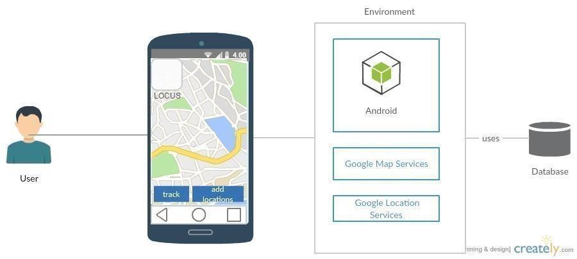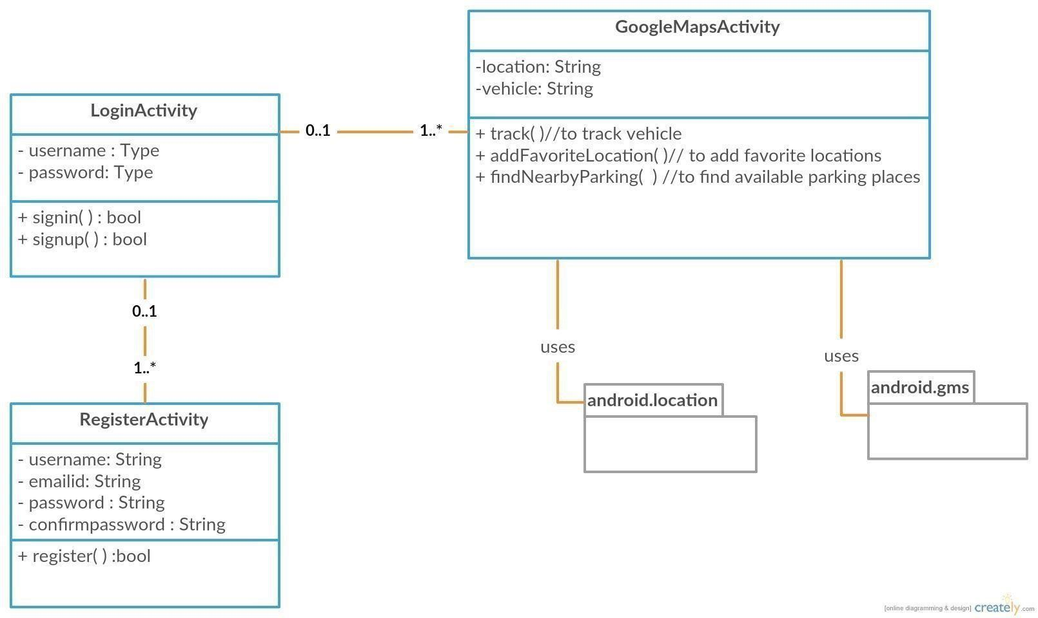

**SEQUENCE DIAGRAM:**

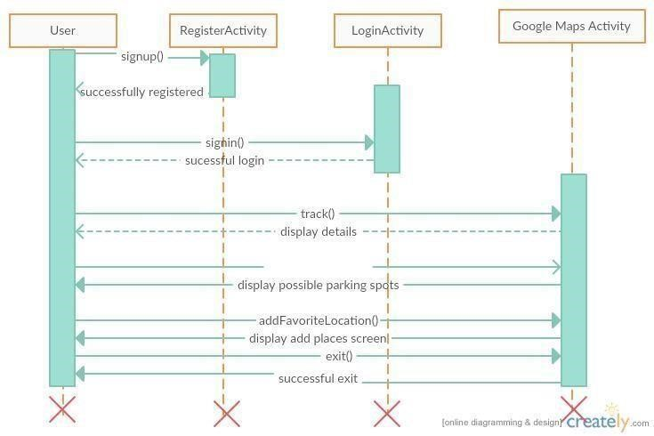

**ISSUES TOOLBAR:**

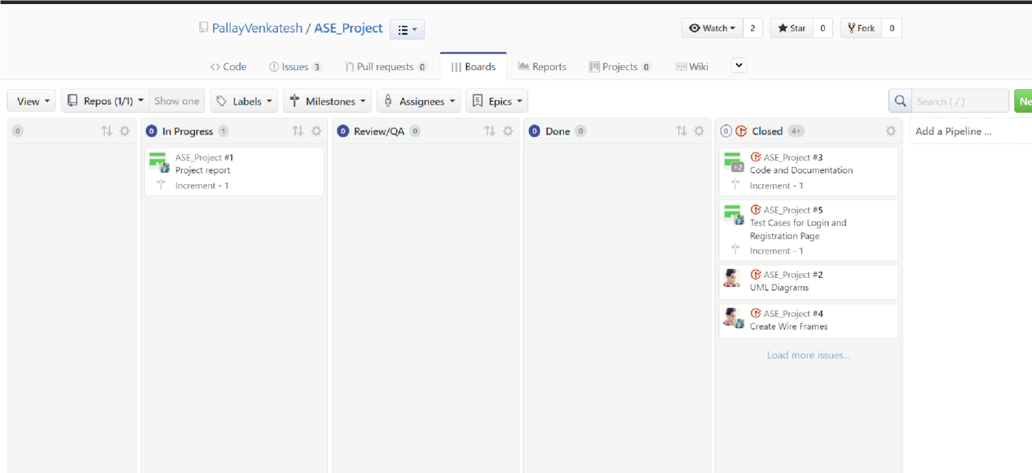

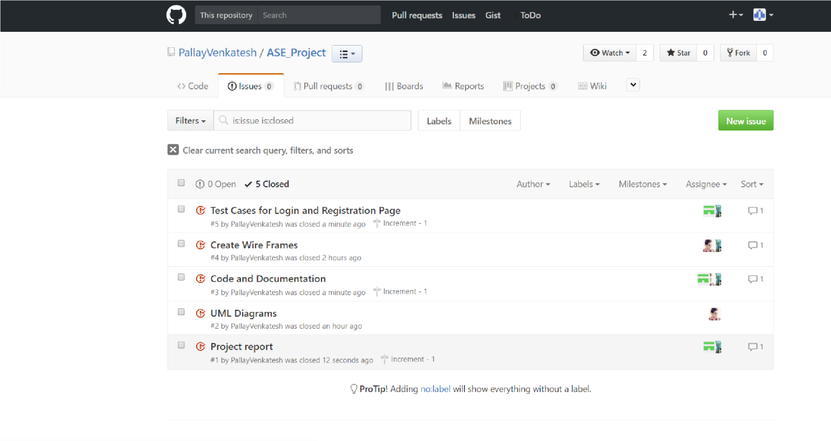

**BURNDOWN GRAPH**:

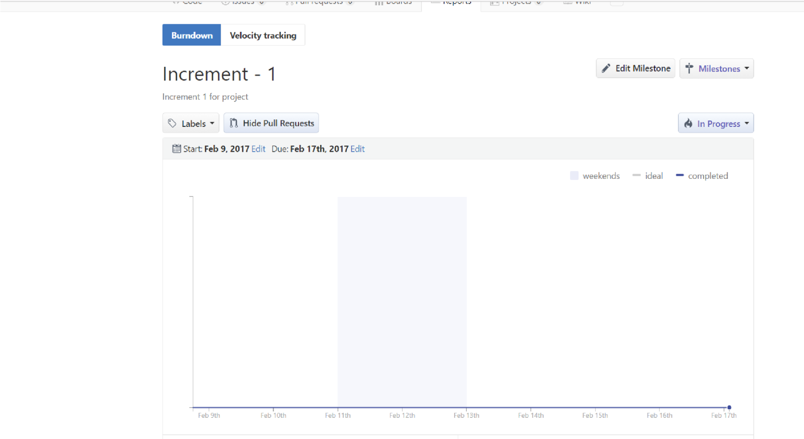

WIREFRAME

LOGIN PAGE

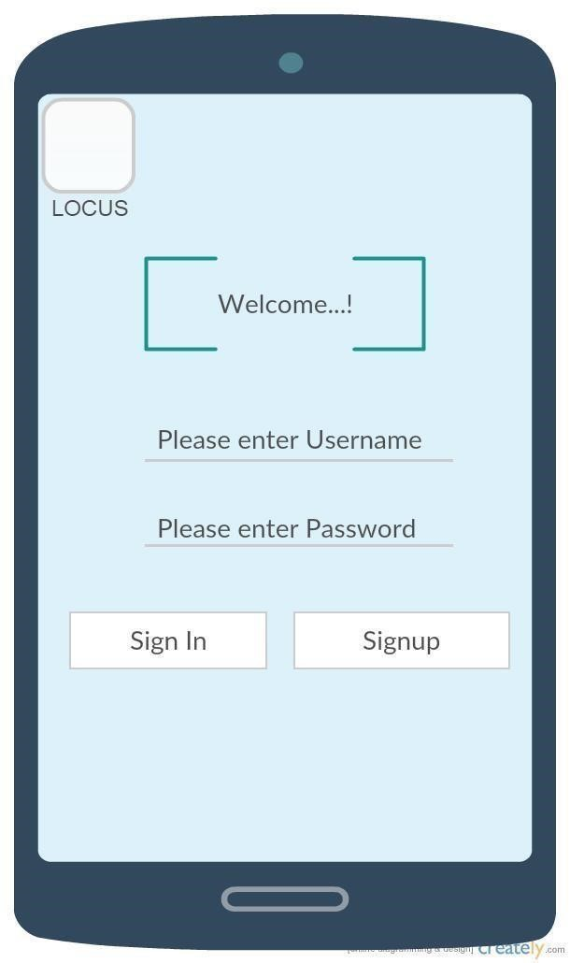

REGISTRATION PAGE:

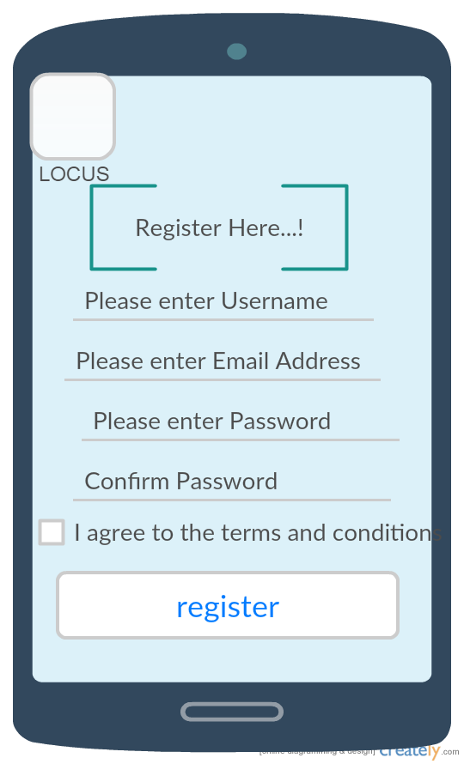

**MOCK-UPS:**

LOGIN PAGE:

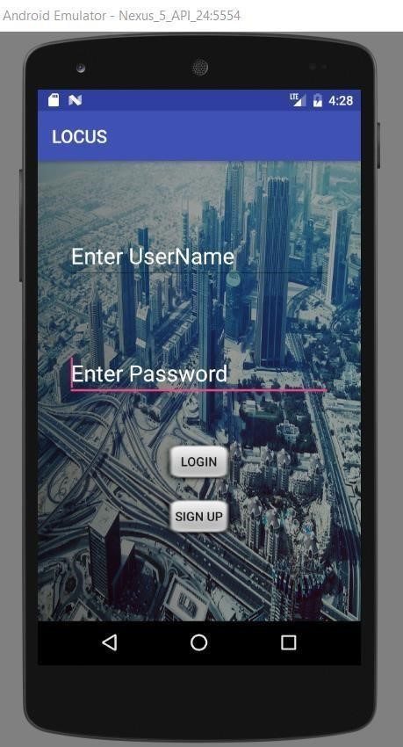

LOGIN PAGE VALIDATION:

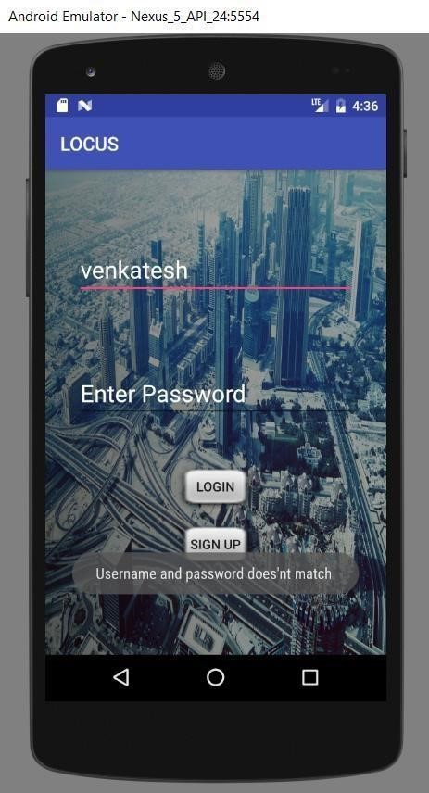

REGISTER PAGE:

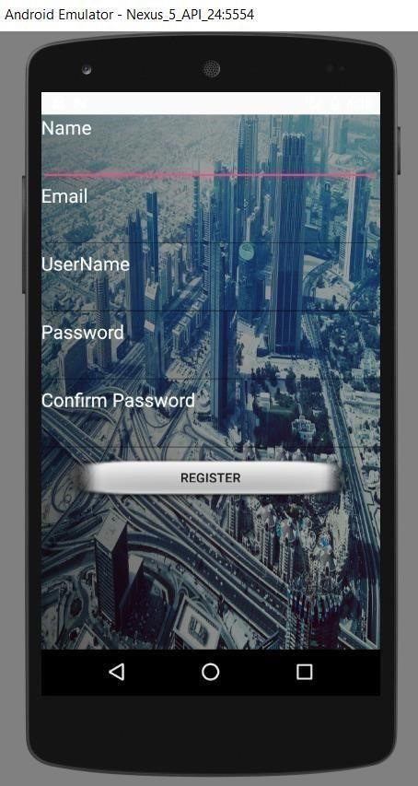

REGISTER PAGE VALIDATION:

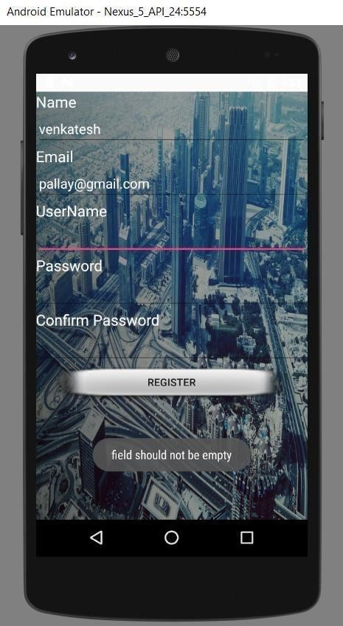

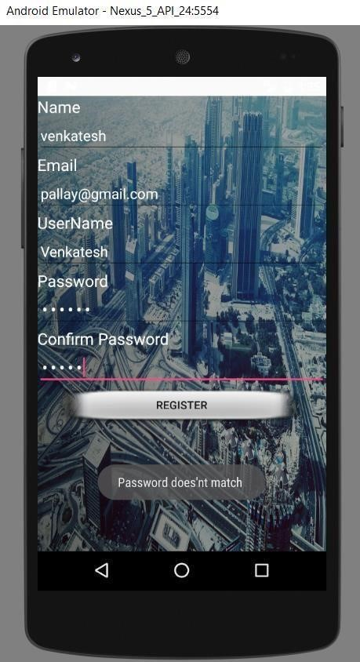

**TEST CASES:**

|  |  |  |  |
| --- | --- | --- | --- |
| **Test Case**  **Name** | **Test Description** | **Expected Results** | **Pass/Fail** |
| Login | Enter Invalid Userid and Invalid Password | Invalid Login Error Message should be displayed | Pass |
|  | Enter Valid Userid and Invalid Password | Invalid Login Error Message should be displayed | Pass |
|  | Enter Valid Userid and Valid Password | Application Should Be Redirected to Home page | Pass |
|  |  |  |  |
| Sign Up | Enter Email Id without @ | Invalid Email id should be displayed | Pass |
|  | Enter different confirm password | Invalid Error Message should be displayed | Pass |
|  | Blank Spaces | Invalid Message should be displayed | Pass |
|  |  |  |  |

**FINAL SCREEN SHOTS:**

LOGIN PAGE**:**



REGISTER PAGE:



